Automated Detection and Temporal Tracking of Potential illegal Mining Using Sentinel-2 Satellite Imagery and Deep Learning
AUTHOR: ROHIT BANSAL , Siaf khan
Affiliation: School of Computer Science Engineering and Technology, Bennett University, Greater Noida, UP, India

ABSTRACT :
Illegal mining poses a devastating threat to ecological stability, yet conventional surveillance techniques remain too sluggish and resource-intensive to counter rapid unlicensed operations. This paper introduces MineWatch, an automated, end-to-end deep learning pipeline designed to identify and temporally monitor illegal mining footprints using freely available Sentinel-2 multispectral imagery. We trained an EfficientNet-B0 classifier on a custom dataset of 11,600 manually labeled image patches extracted from Three Indian mining sites. The model achieved a test accuracy of 92.79% and an F1-score of 0.94, outperforming several existing benchmarks. Utilizing a sliding window inference engine, the system processes high-resolution satellite tiles to generate probability heatmaps and binary detection masks. A five-year temporal analysis (2021–2025) of tile T45QUE revealed a 10.5% net increase in mining area, alongside a detailed change-detection matrix categorizing persistent, new, and recovered mining zones.
I. Introduction:
A. Background and Motivation
- The Shadow Economy of Mining: India is a leading global mineral producer, but parallel to its legal sector is a rapidly expanding shadow economy of unregulated illegal mining.
- Ecological Threat: These illicit operations cause severe environmental damage, including deforestation, soil erosion, river contamination, and a loss of biodiversity.
- Inefficiency of Current Surveillance: Traditional methods, which rely on human analysts manually examining satellite imagery or expensive aerial surveys, are too sluggish and costly to keep up with the fast advancement of unlicensed mining.
- The Deep Learning Paradigm: Advancements in Convolutional Neural Networks (CNNs) can now detect the spectral and textural features of disturbed earth automatically, processing hundreds of square kilometers in minutes instead of weeks.
B. Problem Statement
- The Detection Gap: Because of the vastness and remote nature of Indian mining sites, illicit mining activities can go unchecked for months or years before regulatory action is taken.
- Technological Barriers: Existing high-accuracy methods often rely on complex Synthetic Aperture Radar (SAR) data or require specialized machine learning knowledge that local forest officers and environmental regulators do not possess.
- The Objective: There is a critical need for a localized, lightweight pipeline that takes publicly available Sentinel-2 optical imagery, runs an automated classifier, and provides temporal expansion analysis via a deployable web interface.

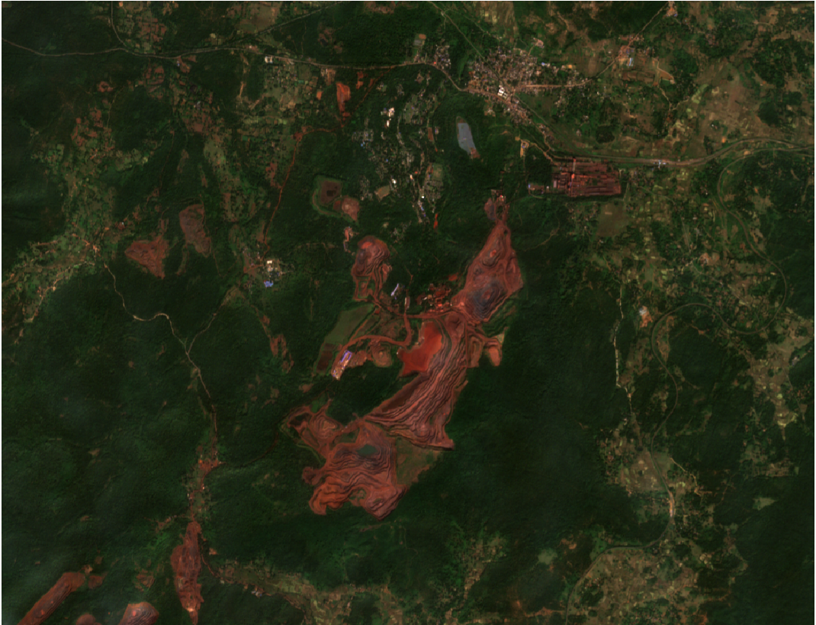
Figure 1: Raw Sentinel-2 True Color Imagery (TCI) highlighting the sprawling and irregular geographical footprints characteristic of unregulated open-pit mining operations in India, which evade traditional ground-level monitoring.

C. Contributions
Custom Localized Dataset: The curation of a proprietary dataset containing 11,600 manually labeled 64x64 pixel image patches derived from five operational Indian mining sites.
Optimized Architecture: The development of an EfficientNet-B0 based classification model that achieves state-of-the-art test accuracy (92.79%) and an F1-score of 0.94.
Temporal Tracking Matrix: A comprehensive five-year temporal analysis (2021–2025) of tile T45QUE, introducing a change detection methodology that categorizes terrain into persistent mining, new expansion, and recovered land.
Accessible Software Integration: The packaging of the entire pipeline into "MineWatch", a multi-page Streamlit web application designed for environmental regulators without requiring machine learning expertise.
D. Paper Organization
The remainder of this paper is organized as follows:
Section II (Literature Review): Reviews existing literature on remote sensing and deep learning applied to land use change and mining detection.
Section III (Methodology): Details the core architecture of the MineWatch system, subdivided into:
1. Dataset: Outlines the extraction and labeling of the 11,600 Sentinel-2 patches.
2. Method/Technique: Details the EfficientNet-B0 two-phase transfer learning architecture.
3. Simulation: Explains the geospatial sliding window inference engine and the Streamlit web application deployment.
4. Discussion: Discusses the methodological choices, including the use of 10-meter optical imagery over SAR data.
Section IV (Results): Presents the model benchmark comparisons, the temporal mining area analysis (2021–2025), and the multi-class change detection matrix.
Section V (Conclusion): Summarizes the project's achievements against its initial goals and outlines future directions for national-scale deployment

II. LITERATURE REVIEW

S. No |  | Problem Statement | Methodology | Results | Shortcomings / Future Work
1 |  | Lack of large-scale systems to detect illegal mines and tailings dams. | Fully Convolutional Neural Networks trained on Sentinel-2 imagery using Google Earth Engine. | Discovered 263 unregistered mines at country scale. | False positives in dam-like structures; needs region-specific tuning.
2 |  | Difficulty in detecting fine-scale gold mining changes over time. | ReCNN (CNN + LSTM) using multi-temporal Sentinel-2 images. | High accuracy change detection of mining ponds. | Requires labeled temporal data; computationally intensive.
3 |  | Mining-induced subsidence hard to distinguish from other deformation. | SBAS-InSAR with DeepLabv3+ CNN on deformation maps. | Detected 202 subsidence areas including forested zones. | Relies on SAR data quality; region-specific training.
4 |  | Manual monitoring of open-pit mines is inefficient. | Improved Mask R-CNN with transfer learning on high-resolution images. | Accurate open-pit mine boundary detection. | High compute cost; not designed for dense forests.
5  6  7  8  9  10 | Illegal aggregate mining difficult to monitor at large scale.  Accurate detection of mining subsidence basins using radar data.  Wide-area automatic detection of mining subsidence regions.  Need for accurate mining land-cover classification.  Detection of deforestation linked to mining activities.  Monitoring illegal river dredging transport activities. |  | Transfer learning with DenseNet and ResNet on satellite images.  Sentinel-1A SAR; D-InSAR; CNN feature extraction (AlexNet, VGG19, ResNet50) with AFSA-optimized SVM.  InSAR deformation maps combined with Mask R-CNN for segmentation.  High-resolution UAV imagery; U-Net convolutional neural network.  Sentinel-2 imagery; DeepLabv3+ semantic segmentation.  CNN-based object detection for truck recognition | Over 90% accuracy in detecting mining machinery.  Achieved up to 90.6% detection accuracy.  Improved large-area subsidence detection and boundary accuracy.  Improved land-cover segmentation accuracy in mining areas.  High accuracy in identifying deforested regions.  Accurate real-time vehicle detection. | Detects machinery, not land deformation directly.  Limited to subsidence detection; requires complex SAR preprocessing.  Performance depends on deformation map quality.  Requires UAV data; limited large-scale applicability.  Focuses on deforestation, not direct mining detection.  Camera-based system; not suitable for satellite-scale monitoring.

III. METHODOLOGY
1. Dataset Collection and Preprocessing:
The foundation of the MineWatch system relies on high-quality, localized training data. Rather than relying on existing generic land-cover datasets, we built a custom, proprietary dataset from scratch to capture the specific spectral and textural signatures of Indian open-pit mining operations.Data Acquisition The raw data collection began with the European Space Agency’s (ESA) Copernicus Data Space Browser. We specifically targeted Sentinel-2 Level-2A True Color Imagery (TCI). Level-2A was chosen because it provides bottom-of-atmosphere surface reflectance, meaning atmospheric corrections have already been applied, which reduces cloud shadow and aerosol noise. We queried imagery across several distinct Indian mining sites, filtering strictly for days with near-zero cloud cover to ensure clean spectral signatures.

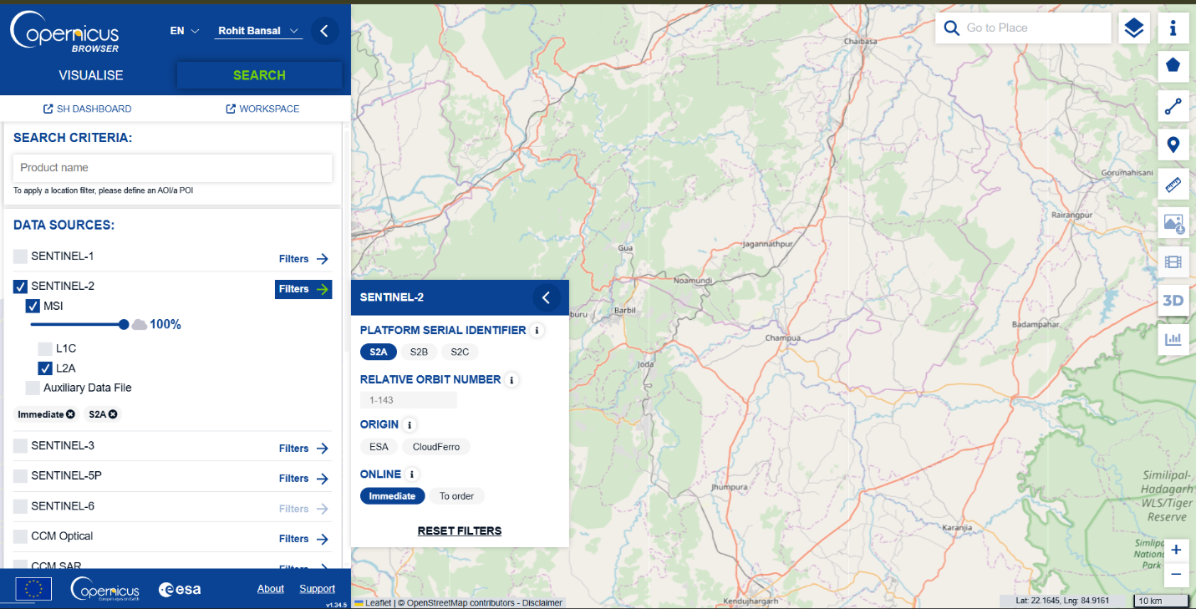

Figure X: The ESA Copernicus Data Space Browser interface, showing the search parameters used to filter for Sentinel-2 MSI Level-2A acquisitions with minimal cloud cover.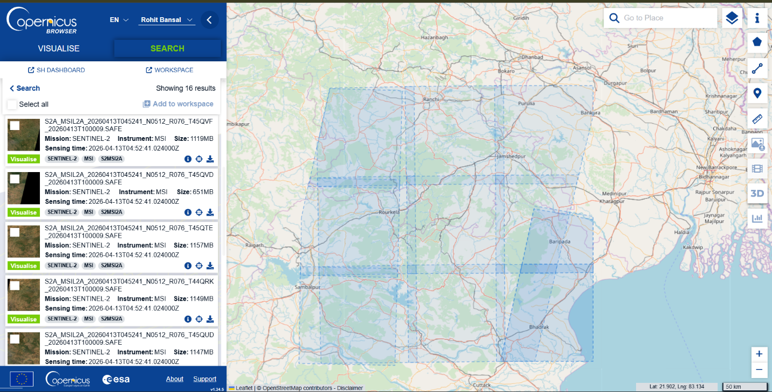 Figure X: Selection of specific geographic grid tiles (e.g., T45QUE) over the Indian subcontinent to isolate regions with known active and historical mining footprints.
Geospatial Extraction via QGIS A standard Sentinel-2 JP2 tile is massive—nominally 10,980 × 10,980 pixels at a 10-meter native spatial resolution. Feeding these raw, gigabyte-sized scenes directly into a deep learning model is computationally impossible on standard hardware. Therefore, the next phase required isolating our regions of interest.
We imported the raw JP2 files into QGIS 3.x. Using the geographic coordinate bounds of our target mining zones, we manually clipped the vast scenes down into smaller, highly concentrated geographic regions. This step was crucial to strip away vast expanses of irrelevant terrain and focus purely on the boundaries where active mining meets natural vegetation.
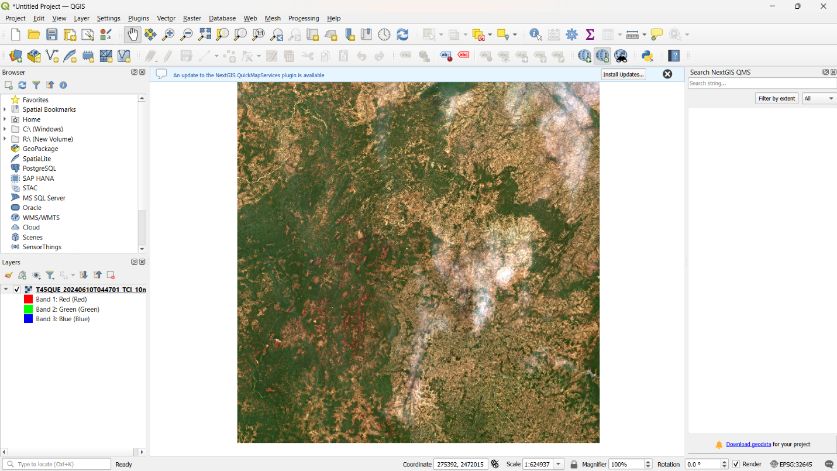
Figure X: A raw Sentinel-2 tile loaded into the QGIS 3.x workspace. From here, specific geographic extents were clipped and exported to isolate concentrated mining activity.
Patch Generation and Manual Labeling To make the imagery digestible for our Convolutional Neural Network, we wrote a Python script to slice the clipped QGIS outputs into uniform 64 × 64 pixel patches. At 10 meters per pixel, each individual patch represents a physical geographic footprint of roughly 409,600 square meters. We chose a 64×64 dimension because it provides the CNN with enough spatial context to recognize the shape of an excavation site, while remaining small enough to allow for rapid batch processing.
This patching process yielded tens of thousands of image fragments. What followed was a highly labor-intensive manual sorting process. Our team visually inspected and manually classified 11,600 individual patches into distinct folders.
The data was sorted into two primary classes:
  - Mining: Patches containing active excavation faces, mining ponds, and fresh tailings.

  - Non-Mining: Patches containing dense vegetation, agricultural fields, barren rock, and dry riverbeds (which frequently cause false positives in automated systems).
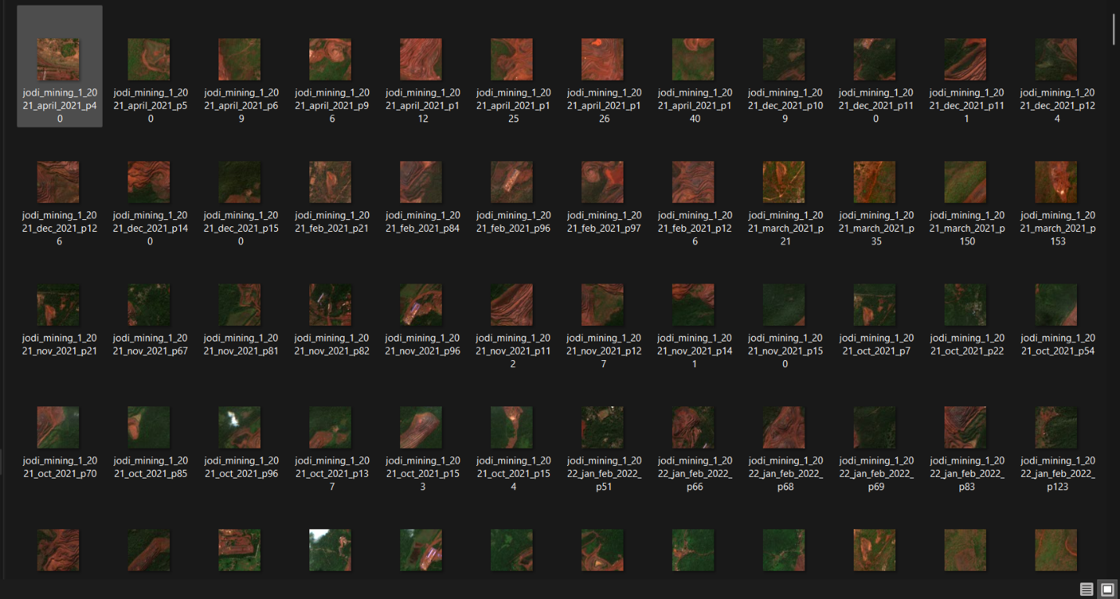

Figure X: A snapshot of the manually sorted "Mining" class directory. Notice the distinct reddish-brown spectral signature of freshly excavated topsoil and exposed mineral faces.

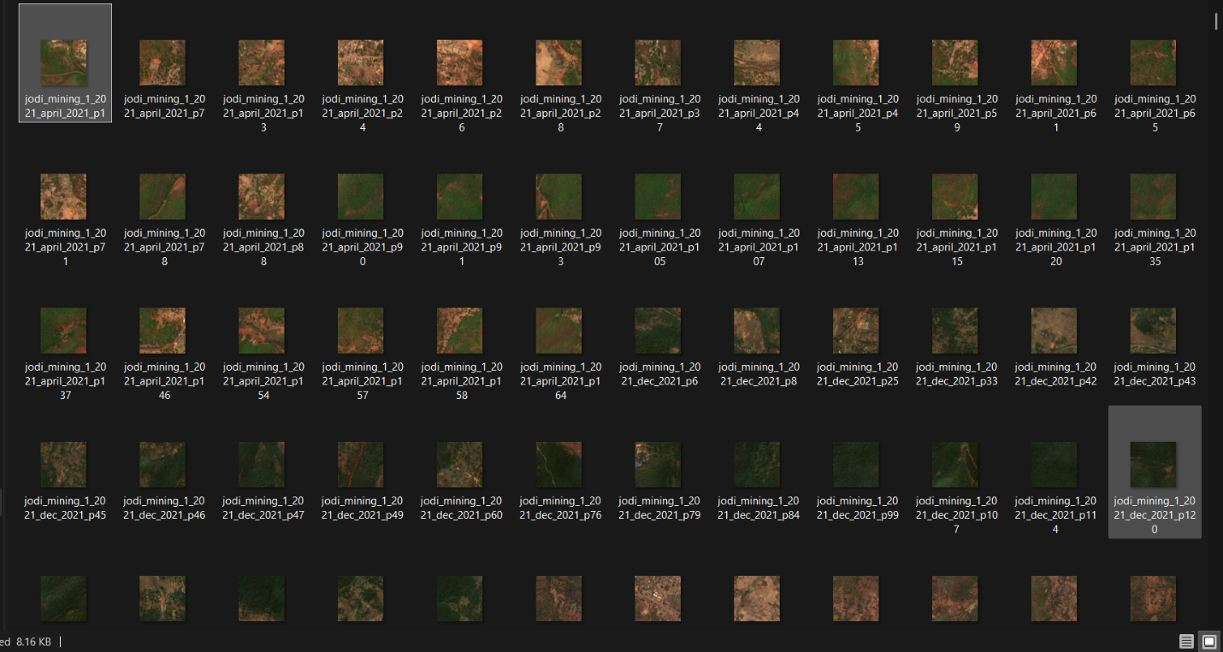

Figure X: Samples demonstrating the visual variability within the dataset, capturing transitional edges where mining activity encroaches upon forested areas.

2. Method and Technique:
Data Preparation and Augmentation:
Before feeding the data into the neural networks, the raw 64×64 pixel patches underwent a strict preprocessing pipeline. The pixel values were first normalized to a [0, 1] float32 scale to ensure mathematical stability during gradient descent. Because our advanced transfer-learning architectures expect larger inputs, all patches were bilinearly resized to 224×224 pixels. To artificially expand our training data and prevent the models from memorizing specific pixel orientations (overfitting), we applied a series of transformations: horizontal flipping, random rotations up to 20 degrees, and color jittering. Finally, the dataset was divided using a stratified split (seed = 4) into 70% training, 15% validation, and 15% testing sets, ensuring a balanced representation of mining and non-mining classes.
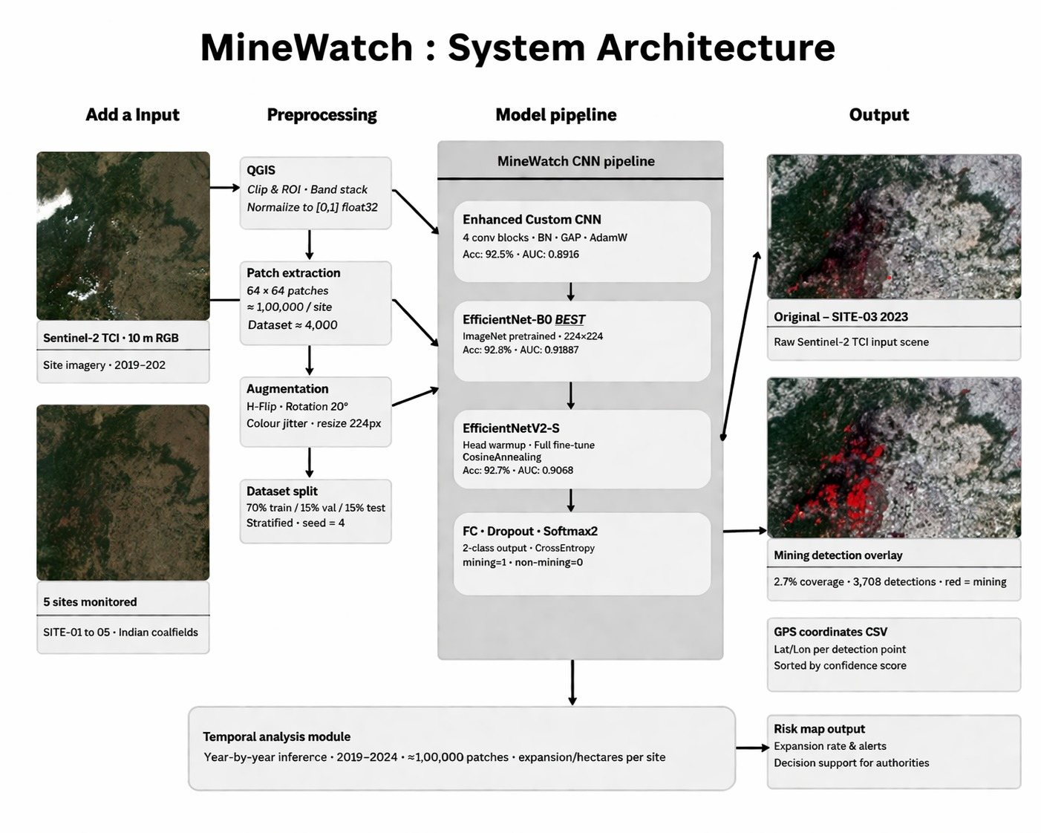 Figure X: The MineWatch System Architecture. This diagram illustrates the data flow from Sentinel-2 RGB ingestion through the CNN model pipeline, highlighting the progression toward the final geospatial detection overlays.

Model Architectures and Training Pipeline
To establish the most robust and computationally efficient classifier for our sliding-window inference engine, we systematically trained and evaluated six distinct Convolutional Neural Network (CNN) architectures:
- Custom CNN (Baseline): A standard foundational network built from scratch to establish baseline spatial feature extraction capabilities.
- Enhanced Custom CNN: An upgraded proprietary architecture featuring 4 sequential convolutional blocks, Batch Normalization (BN) for training stability, Global Average Pooling (GAP) to prevent spatial overfitting, and optimized using AdamW.
- ResNet-18: A transfer learning approach utilizing deep residual connections (skip connections) to mitigate the vanishing gradient problem, pre-trained on ImageNet.
- MobileNetV2: A lightweight transfer learning architecture designed for high efficiency, utilizing inverted residuals and linear bottlenecks to reduce memory footprint.
- EfficientNetV2-S: A modern, state-of-the-art architecture (21.5 million parameters) utilizing progressive learning and fused mobile inverted bottleneck convolutions (Fused-MBConv).
- EfficientNet-B0 (Champion Model): A highly optimized architecture utilizing compound scaling (balancing depth, width, and resolution) with only 5.3 million parameters.
Two-Phase Transfer Learning Protocol:
For the pre-trained models (ResNet, MobileNet, and the EfficientNet family), we implemented a rigorous two-phase training protocol to adapt them to satellite imagery without destroying their learned ImageNet features.
- Phase 1 (Head Warmup): The backbone parameters were frozen. A custom classifier head—comprising a Dropout layer (0.5), a 256-node Linear layer with ReLU, a second Dropout (0.4), and a binary output node—was trained for 10 epochs using the Adam optimizer (lr = $1 \times 10^{-3}$).
- Phase 2 (Full Fine-Tuning): All network layers were unfrozen. Training continued using the AdamW optimizer (lr = $5 \times 10^{-5}$, weight decay = $5 \times 10^{-4}$), with label smoothing of 0.1 and a Cosine Annealing scheduler ($T_{max}=50$) to guarantee convergence and prevent over-confidence.
3. Simulation and Inference Engine:
While achieving high accuracy on isolated 64×64 pixel patches was a critical first step, standard environmental monitoring requires analyzing vast, continuous landscapes. To simulate a real-world regulatory deployment, we engineered a geospatial inference engine capable of processing full-resolution Sentinel-2 GeoTIFF and JP2 files.
The Sliding Window Algorithm : A native Sentinel-2 tile encompasses over 100 million pixels. Because feeding an entire gigabyte-sized scene into a Convolutional Neural Network simultaneously exceeds standard consumer hardware memory, our simulation engine employs a sliding-window algorithm. The system loads the contrast-stretched satellite imagery and sweeps a 64×64 pixel bounding box across the landscape. To prevent blind spots and edge-detection failures, we implemented a 32-pixel stride. This 50% overlap ensures that every geographical coordinate is evaluated multiple times from slightly different spatial contexts.
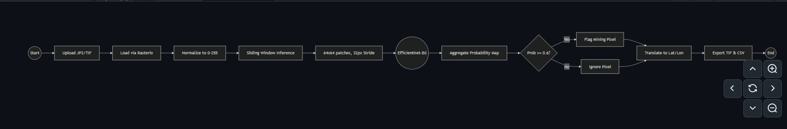 Figure X: Activity diagram illustrating the simulation pipeline, detailing the step-by-step logic from raw tile ingestion through sliding window inference and final area calculation.
Probability Aggregation and Georeferencing As the window traverses the tile, the EfficientNet-B0 classifier head outputs a probability score indicating the likelihood of active mining. Because of the overlapping stride, these predictions are aggregated and averaged to construct a smooth, continuous probability heatmap. To translate this heatmap into an actionable binary mask, the simulation passes the data through a user-defined confidence threshold (optimized empirically at 0.6). Pixels exceeding this threshold are flagged as mining anomalies.
Crucially, the simulation does not just output a flat image. Utilizing the rasterio library, the engine maps the flagged pixel arrays back to their native geographic coordinates. This step outputs a georeferenced overlay (.tif) that can be opened directly in QGIS, alongside a CSV file containing the exact GPS coordinates of every detected mining patch for ground-truth verification.
Temporal Batching and Deployment To track the expansion of mining operations over time, the simulation engine features a batch-processing mode. We simulated a historical audit by feeding the system consecutive yearly imagery (2021–2025) of the identical geographic bounding box. The engine automatically extracted the localized mining footprints, calculated the area in square kilometers, and dumped the year-over-year statistics into a central JSON and CSV registry.
To ensure this entire pipeline is accessible to forestry officials and regulators who lack programming expertise, the backend was wrapped into a deployable Streamlit web application. This interface allows users to upload raw satellite files, tweak the CNN confidence thresholds, and generate spatial risk maps with a single click, all while the system autonomously manages memory clearing (gc.collect()) to prevent hardware crashes during heavy inference loads.

4. Discussion of Methodological Choices:
The architectural and data-pipeline design of MineWatch was driven by a core philosophy: balancing high-end detection accuracy with practical, real-world deployability for local environmental agencies.
Optical Imagery vs. Synthetic Aperture Radar (SAR) A significant portion of contemporary mining research relies on SAR data (such as Sentinel-1) to detect terrain subsidence. While SAR has the distinct advantage of penetrating cloud cover, it requires highly complex preprocessing pipelines (like interferometry) that are computationally expensive and difficult to interpret. We deliberately chose Sentinel-2 Level-2A optical imagery because true-color visual data is universally understood by ground-level forest officers and regulators. The primary trade-off of optical data is cloud obscuration; however, we mitigated this by temporally filtering for cloud-free acquisition days, a viable strategy given Sentinel-2’s high 5-day revisit frequency.
Patch-Based Classification vs. Semantic Segmentation Another critical design choice was formulating the problem as a patch-based classification task rather than pixel-level semantic segmentation (such as U-Net or Mask R-CNN). Semantic segmentation networks require datasets labeled with precise, hand-drawn polygonal masks around every single mining feature. Creating pixel-perfect masks for thousands of Indian mining sites would impose a massive, unrealistic annotation burden. By utilizing a 64×64 pixel patch classification approach with a sliding window, we drastically reduced the manual labeling time while still providing the neural network with sufficient spatial context (roughly 400,000 square meters per patch) to distinguish an open-pit mine from a natural dry riverbed.
Hardware Considerations and Deployability Ultimately, the decision to champion EfficientNet-B0 over the heavier EfficientNetV2-S or ResNet architectures was rooted in deployment realities. Environmental regulatory offices typically operate on standard, consumer-grade hardware lacking high-VRAM graphical processing units. A 5.3-million-parameter model, paired with explicit Python garbage collection (gc.collect()) within the Streamlit inference loop, ensures that the sliding-window engine can process gigabyte-sized full-resolution satellite tiles without triggering memory overflow errors. This approach bridges the gap between theoretical deep learning accuracy and a functional tool that can be installed on a standard agency laptop.

IV. RESULTS
This section presents the empirical findings of the MineWatch system, divided into two primary evaluations: the quantitative benchmarking of the neural network architectures, and the applied geospatial results from our five-year temporal simulation across the target mining zones.
1. Model Benchmarking and Selection
To determine the most robust engine for deployment, all six trained architectures were evaluated against a strictly held-out test set of image patches. The models were assessed across five key metrics: Accuracy, Area Under the Receiver Operating Characteristic Curve (AUC-ROC), F1-Score, Precision, and Recall.
The performance metrics revealed a highly competitive landscape among the transfer-learning architectures:
Model Architecture | Accuracy | AUC-ROC | F1-Score | Precision | Recall
Custom CNN (Baseline) | 0.9167 | 0.9741 | 0.8800 | 0.91 | 0.96
Enhanced Custom CNN | 0.9257 | 0.9785 | 0.9200 | 0.92 | 0.97
ResNet-18 | 0.9189 | 0.9738 | 0.8900 | 0.93 | 0.94
MobileNetV2 | 0.9212 | 0.9734 | 0.9000 | 0.92 | 0.95
EfficientNet-B0 | 0.9279 | 0.9711 | 0.9400 | 0.94 | 0.94
EfficientNetV2-S | 0.9279 | 0.9756 | 0.9300 | 0.94 | 0.95

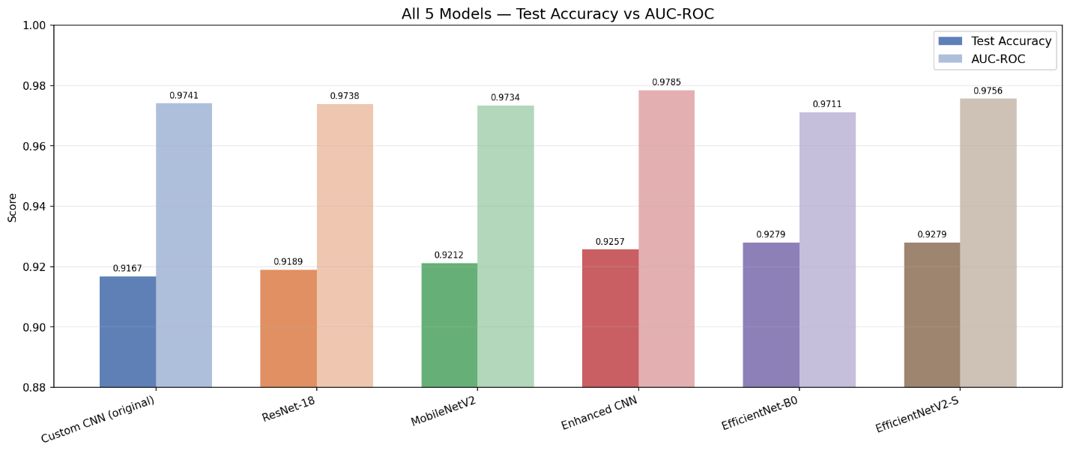
Figure X: Grouped bar chart comparing the Accuracy, AUC-ROC, and F1-Scores across the six evaluated architectures.
While both EfficientNet-B0 and the heavier EfficientNetV2-S achieved an identical, state-of-the-art test accuracy of 92.79%, EfficientNet-B0 was officially selected as the champion model for the inference pipeline. This decision was dictated by computational efficiency. Because our sliding-window simulation must scan millions of pixels across full-resolution tiles, inference speed is paramount. EfficientNet-B0 achieved a premier F1-score of 0.94 using only 5.3 million parameters—drastically fewer than the 21.5 million required by EfficientNetV2-S. This makes B0 exponentially faster and significantly more stable for deployment on standard government or consumer hardware.

2. Temporal Expansion Tracking (2021–2025)
Beyond isolated patch accuracy, the true value of MineWatch lies in its ability to quantify ecological destruction over time. We applied the finalized EfficientNet-B0 pipeline to a continuous five-year stack of Sentinel-2 imagery across tile T45QUE.
The simulation successfully tracked the exact scale of illegal expansion. The model outputs revealed that the net mining footprint grew from 155.95 km² in 2021 to 172.34 km² in 2025, representing a +10.5% net expansion over the observation period.
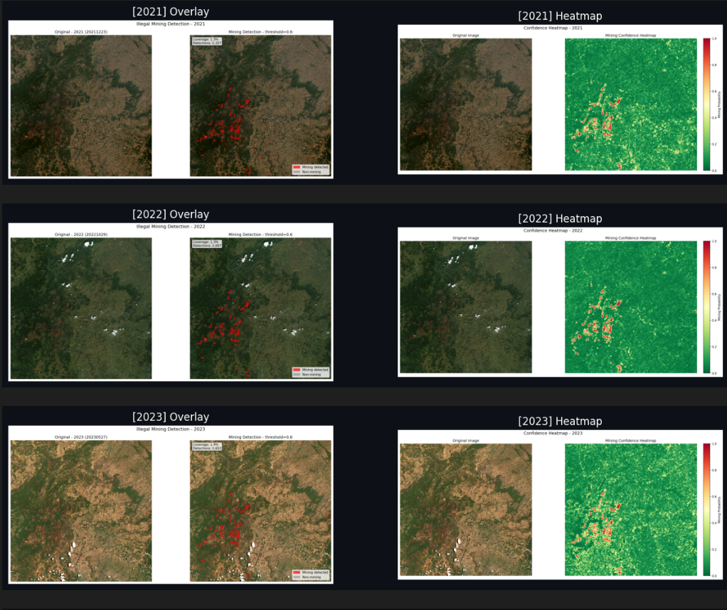 Figure X: Automated temporal outputs (2021–2023) showcasing both the continuous probability heatmaps (right) and the finalized binary detection overlays (left) mapped directly onto the satellite imagery.
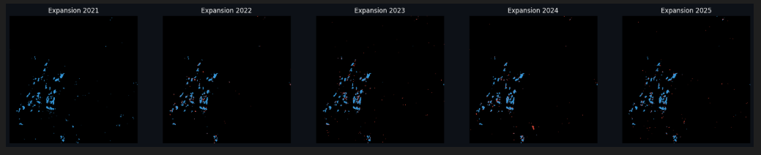 Figure X: Geospatial progression of the mining expansion mapped dynamically across the five-year observation period, highlighting directional growth trends.
3. Multi-Class Change Detection
To provide actionable intelligence for environmental regulators, it is not enough to simply state the total area. We post-processed the binary masks to categorize the terrain changes year-over-year into three distinct ecological states: Persistent Mining, New Expansion, and Recovered Land.
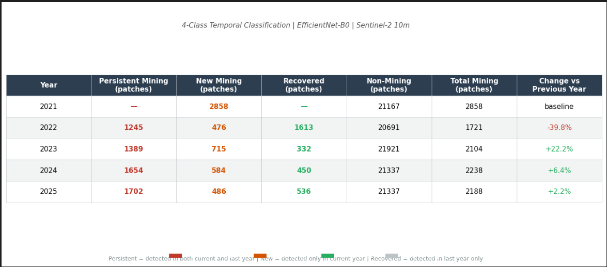 Table X: Multi-Class Temporal Classification based on EfficientNet-B0 predictions, tracking precise numerical patch changes and total area fluctuations year over year.
By comparing the 2021 baseline directly against the 2025 outputs, the system generated a comprehensive change map. The analysis recorded 150.20 km² of Persistent Mining—areas that have been subjected to continuous, uninterrupted extraction for half a decade. Conversely, the model identified 17.63 km² of Recovered Land, indicating regions where mining ponds had dried up, topsoil 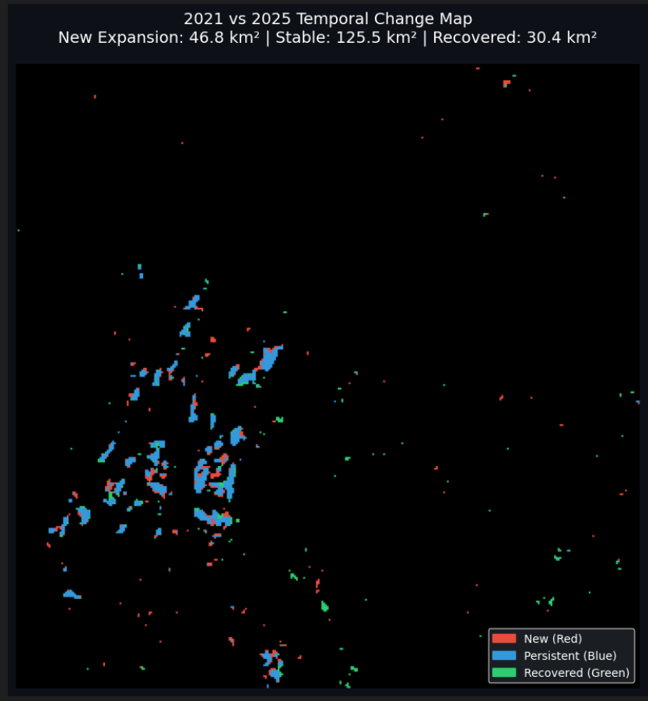 Figure X: 2021 vs. 2025 Temporal Change Map. Red areas indicate new expansion, blue indicates persistent multi-year mining, and green denotes recovered landscape.
The high volume of persistently mined area heavily underscores regions requiring immediate, targeted regulatory intervention. Meanwhile, the localized red patches (New Expansion) perfectly illustrate the model's sensitivity to fresh deforestation and the breaking of new ground.

V. CONCLUSION
The unchecked proliferation of illegal mining presents a critical ecological challenge that traditional, manual surveillance methods are simply too slow to address. In this study, we introduced MineWatch, an automated, end-to-end deep learning pipeline designed to directly bridge the gap between advanced remote sensing research and practical, on-the-ground environmental enforcement.
By fine-tuning the highly efficient EfficientNet-B0 architecture on a custom, localized dataset of 11,600 Sentinel-2 image patches, we demonstrated that state-of-the-art detection (92.79% test accuracy and a 0.94 F1-score) is entirely achievable using solely free, open-access optical imagery. Rather than relying on computationally heavy synthetic aperture radar (SAR) or complex time-series prerequisites, our approach proves that a lightweight, patch-based sliding window classifier can effectively isolate the irregular spectral signatures of open-pit mining in the Indian subcontinent.
Furthermore, the five-year temporal simulation (2021–2025) successfully translated these raw neural network classifications into actionable ecological intelligence. By tracking a 10.5% net expansion in the target mining footprint and categorizing the terrain changes into Persistent Mining, New Expansion, and Recovered Land, the system provides regulators with a clear historical matrix detailing exactly where intervention is needed most. Packaging this entire inference engine into a deployable, memory-managed Streamlit web application ensures that this technology is not just a theoretical academic exercise, but a functional tool that can be run on the standard hardware of local forestry and environmental agencies.
Future Work Future development of the MineWatch system will focus on expanding its geographical robustness. We plan to implement semi-supervised pseudo-labeling to scale the model for national deployment without requiring exhaustive manual annotation. Additionally, integrating the Sentinel-2 QA60 cloud mask band will allow for fully autonomous, multi-temporal pipeline execution. Finally, incorporating near-infrared (Band 8) inputs will be explored to further suppress false positives frequently caused by seasonal dry riverbeds and barren agricultural topsoil.

VI. REFERENCES
[1] Balaniuk, R., Mack, J., Foss, E., & Costa, P. (2020). Mining and Tailings Dam Detection in Satellite Imagery Using Deep Learning. Sensors, 20(23), 6936.
[2] Camalan, S., Cui, K., Pauca, V. P., Alqahtani, S., Silman, M., Chan, R., ... & Lutz, D. A. (2022). Change Detection of Amazonian Alluvial Gold Mining Using Deep Learning and Sentinel-2 Imagery. Remote Sensing, 14(7), 1746.
[3] Xi, W., Tang, P., & Yan, T. (2023). Automatic Identification of Mining-Induced Subsidence in Complex Geological Environments Using Deep CNNs. IEEE Journal of Selected Topics in Applied Earth Observations and Remote Sensing.
[4] Wang, Z., Xia, J., Zhu, Z., & Wei, J. (2020). Automatic Identification of Open-Pit Mines Using the Improved Mask R-CNN and Remote Sensing Images. Remote Sensing, 12(12), 1–20.
[5] Yesilmen, O., Bashan, M., & Kaplan, G. (2022). CNN-Based Monitoring of Aggregate Mining and Rehabilitation Using Unmanned Aerial Vehicle and Satellite Images. Case Studies in Construction Materials, 17, e01237.
[6] Zhang, X., Liu, Y., & Li, J. (2022). Automatic-Detection Method for Mining Subsidence Basins Based on InSAR and CNN-AFSA-SVM. Sustainability, 14(12), 7478.
[7] Liu, Z., Hou, J., & Wu, G. (2024). Mask R-CNN Network for Wide-Area Mining Subsidence Automatic Detection With InSAR Observations. IEEE Transactions on Geoscience and Remote Sensing, 62, 1–14.
[8] Ma, L., Li, M., Ma, X., Cheng, L., Du, P., & Liu, Y. (2020). U-Net Convolutional Networks for Mining Land Cover Classification Based on High-Resolution UAV Imagery. IEEE Access, 8, 60827–60840.
[9] de Bem, P. P., de Carvalho Junior, O. A., Fontes Guimarães, R., & Gomes, R. A. T. (2020). Change Detection of Deforestation in the Brazilian Amazon Using Deep Learning. Remote Sensing, 12(6), 901.

